ZOMATO RESTAURANT DATA ANALYSIS
Exploratory Data Analysis, Visualization and Business Insights

Prepared By: [POTNURU JAYANTH ABHINAY]
Organization / Institute: HANOMINDS LEARNING TECHNOLOGIES
Dataset: cleaned_zomato_data.csv
Date: 08 August 2026
Tools Used: Python, Pandas, NumPy, Matplotlib, Seaborn, Jupyter Notebook / VS Code / Google Colab
Project Type: College / Internship / Portfolio Data Analysis Project

2. Executive Summary
This project analyzes a cleaned Zomato restaurant dataset containing 148 restaurant records and 8 columns. The analysis focuses on restaurant type, online ordering, table booking, ratings, customer votes, and approximate cost for two people.
The dataset contains 148 rows with no missing values and no exact duplicate rows. The average restaurant rating is 3.63, the median rating is 3.70, the average number of votes is 264.81, and the average approximate cost for two people is ₹418.24.
Dining is the largest restaurant category with 110 records. Cafes have an average rating of 3.77, while the 'other' category has the highest average rating at 3.91 among the four listed types. Only 8 of 148 restaurants have table-booking availability, showing that table booking is uncommon in this sample.
The correlation between votes and ratings is 0.49, indicating a moderate positive relationship in this dataset. Votes and approximate cost have a weaker positive relationship of 0.32. These relationships should be treated as associations rather than proof that one variable causes another.
The final outcome is a business-oriented exploratory analysis that identifies restaurant mix, customer engagement patterns, pricing differences, booking availability, and relationships among key numeric variables. The findings can support restaurant benchmarking, pricing discussions, digital-ordering decisions, and customer-engagement strategies.

3. Introduction
Zomato-style restaurant data can help businesses understand how restaurants differ in pricing, ratings, customer engagement, online ordering, and table-booking availability. Data analysis converts these raw records into understandable patterns and measures.
This project uses Python-based exploratory data analysis (EDA). EDA means studying a dataset before building advanced models. It helps identify distributions, relationships, unusual values, and business patterns.
The analysis is important because restaurant businesses operate in a competitive market. Understanding which restaurant types are common, how much customers may spend, how many votes restaurants receive, and whether digital services are available can help management make better decisions.

4. Problem Statement
The business problem is to understand the characteristics and customer-engagement patterns of restaurants in the supplied Zomato dataset. The analysis should answer questions about restaurant categories, ratings, votes, pricing, online ordering, and table booking.
- Identify the dominant restaurant types in the dataset.
- Measure typical ratings, votes, and approximate cost.
- Understand the availability of online ordering and table booking.
- Compare pricing across restaurant types and table-booking availability.
- Study relationships among ratings, votes, and approximate cost.
- Convert the findings into practical business recommendations.

5. Project Objectives
- Understand the structure of the Zomato dataset.
- Verify data quality and identify missing or duplicate records.
- Convert the rating field into a numeric feature for analysis.
- Perform univariate, bivariate, and multivariate analysis.
- Create meaningful visualizations.
- Identify patterns supported by the actual data.
- Translate statistical observations into business insights.
- Provide actionable recommendations without making unsupported claims.

6. Dataset Description
Item | Value
Dataset Name | cleaned_zomato_data.csv
Source | User-provided cleaned Zomato dataset
Rows | 148
Columns | 8
Exact Duplicate Rows | 0
Missing Values | 0
Unique Restaurant Names | 145

6.1 Column Description
Column | Data Type / Class | Description
name | Text | Restaurant name
online_order | Categorical | Whether online ordering is available (Yes/No)
book_table | Categorical | Whether table booking is available (Yes/No)
rate | Text / rating string | Restaurant rating stored in a format such as 4.1/5
votes | Numerical | Number of customer votes
approx_cost(for two people) | Numerical | Approximate cost for two people
listed_in(type) | Categorical | Restaurant type/category

A derived numerical column named 'rating' was created by extracting the numeric part of the original 'rate' field. This feature is used for averages, distributions, and correlation analysis.

7. Business Questions
- Which restaurant type has the largest number of restaurants?
- What are the typical restaurant rating, vote count, and approximate cost?
- How common is online ordering?
- How common is table booking?
- Which restaurant type has the highest average rating?
- How does average cost vary by restaurant type?
- Does table-booking availability differ in average cost?
- Is there a relationship between votes and ratings?
- Is there a relationship between votes and approximate cost?
- Which restaurants have the highest number of customer votes in this sample?

8. Tools and Technologies
Tool | Purpose | Real-world use
Python | Programming language | Automates data preparation and analysis
Pandas | Data manipulation | Loads, cleans, groups, and summarizes tabular data
NumPy | Numerical operations | Supports numerical calculations and arrays
Matplotlib | Data visualization | Creates charts for reporting and analysis
Seaborn | Statistical visualization | Useful for advanced statistical charts and heatmaps
Jupyter Notebook / VS Code / Google Colab | Development environment | Run code, document analysis, and share work

9. Project Workflow
Problem Statement
↓
Dataset Collection
↓
Import Libraries
↓
Load Dataset
↓
Data Exploration
↓
Data Cleaning
↓
Exploratory Data Analysis
↓
Univariate Analysis
↓
Bivariate Analysis
↓
Multivariate Analysis
↓
Feature Engineering
↓
Data Visualization
↓
Business Insights
↓
Recommendations
↓
Conclusion

Workflow Explanation
Step | Explanation
Problem Statement | Define the business questions that the data should answer.
Dataset Collection | Obtain the supplied cleaned restaurant dataset.
Import Libraries | Load Python libraries required for data handling and visualization.
Load Dataset | Read the CSV file into a Pandas DataFrame.
Data Exploration | Understand rows, columns, data types, and basic statistics.
Data Cleaning | Check missing values, duplicates, data types, and consistency.
EDA | Study distributions and relationships in the data.
Univariate Analysis | Analyze one variable at a time.
Bivariate Analysis | Compare two variables to identify relationships.
Multivariate Analysis | Study several numeric variables together using correlation and grouped analysis.
Feature Engineering | Create a useful numeric rating feature from the original rating text.
Visualization | Present important findings through charts.
Business Insights | Translate results into understandable business observations.
Recommendations | Suggest actions supported by the findings.
Conclusion | Summarize the overall result and business value.

10. Data Loading
The dataset is stored as a CSV file. CSV means Comma-Separated Values. It is a common format for storing table-like data.
Beginner-friendly code:
import pandas as pd
df = pd.read_csv('cleaned_zomato_data.csv')
print(df.head())
A DataFrame is the main table structure used by Pandas. It is similar to a spreadsheet: rows represent records and columns represent fields.

11. Data Exploration
Function | Purpose | Syntax | Business Interpretation
head() | Shows the first five rows | df.head() | Useful for checking whether the data loaded correctly.
tail() | Shows the last five rows | df.tail() | Useful for checking the end of the dataset.
shape | Returns rows and columns | df.shape | Output: (148, 8).
columns | Lists column names | df.columns | Confirms available fields.
dtypes | Shows data types | df.dtypes | Helps identify fields requiring conversion.
info() | Summarizes structure and non-null counts | df.info() | Useful for data-quality checking.
describe() | Provides numeric descriptive statistics | df.describe() | Shows mean, quartiles, minimum and maximum.

11.1 Key Descriptive Statistics
Metric | Mean | Median | Minimum | Maximum | Std. Dev.
Votes | 264.81 | 43.50 | 0 | 4884 | 653.68
Rating | 3.63 | 3.70 | 2.6 | 4.6 | 0.40
Approx. Cost | ₹418.24 | ₹400.00 | ₹100 | ₹950 | ₹223.09

Business interpretation: the median vote count (44) is much lower than the mean (264.81), which indicates that a relatively small number of restaurants have very high vote counts. The rating range is narrower, from 2.6 to 4.6, compared with the much wider spread in votes.

12. Data Cleaning
Area | Observed | Method | Result | Business Impact
Missing values | 0 missing cells | No missing values were found | Complete sample for the supplied fields | No imputation was required
Duplicate rows | 0 exact duplicates | Exact duplicate check | No exact duplicate records | No duplicate removal required
Data types | rate is text; votes/cost are numeric | Convert rating text to numeric feature | Makes rating suitable for statistics | Improves analytical consistency
Empty strings / extra spaces | No empty-string issue observed in the loaded fields | Visual/data checks | No additional correction required | No material impact identified
Column names | One cost column contains punctuation/parentheses | Kept original field name | Preserves source terminology | Readable in code with exact column name
Outliers | Votes have a strong right-skew | Reviewed using descriptive statistics and top-vote records | High-vote restaurants are visible rather than automatically deleted | Avoids removing genuine high-engagement records

Important note: the dataset is already described as a cleaned dataset. Therefore, this report does not claim that missing values or duplicate records were fixed when they were not present. The main analytical preprocessing was converting the rating text into a numeric field.

13. Exploratory Data Analysis (EDA)

13.1 Univariate Analysis - Numerical Columns
Variable | Mean | Median | Min | Max | Q1 | Q3 | Std. Dev.
Votes | 264.81 | 43.50 | 0 | 4884 | 6.75 | 221.75 | 653.68
Rating | 3.63 | 3.70 | 2.6 | 4.6 | 3.30 | 3.90 | 0.40
Approx. Cost | ₹418.24 | ₹400 | ₹100 | ₹950 | ₹200 | ₹600 | ₹223.09

Votes: the distribution is highly uneven because a small number of restaurants have thousands of votes while many restaurants have relatively few. This is visible from the mean of 264.81 versus a median of 43.50.
Rating: ratings are concentrated around the middle-to-upper range, with a mean of 3.63 and median of 3.70.
Approximate cost: the median cost is ₹400 for two people, while the mean is about ₹418.24, showing a moderately spread pricing range.

13.2 Univariate Analysis - Categorical Columns
Variable | Category | Count | Percentage
Restaurant Type | Dining | 110 | 74.3%
Restaurant Type | Cafes | 23 | 15.5%
Restaurant Type | other | 8 | 5.4%
Restaurant Type | Buffet | 7 | 4.7%
Online Order | Yes | 58 | 39.2%
Online Order | No | 90 | 60.8%
Book Table | Yes | 8 | 5.4%
Book Table | No | 140 | 94.6%

14. Bivariate Analysis

Restaurant Type Distribution
Objective: Compare the number of restaurants across the four restaurant types.
Why this chart: A bar chart is suitable for comparing counts across categories.
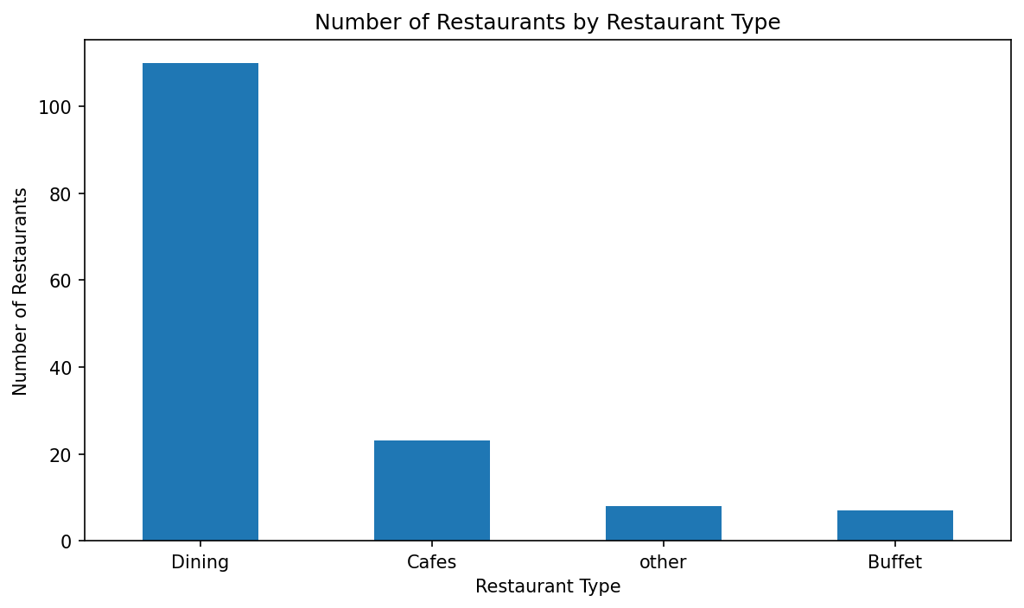
Observation: Dining dominates the sample with 110 of 148 records. Cafes have 23 records, while 'other' and Buffet have 8 and 7 records respectively.
Business interpretation: The dataset is heavily weighted toward Dining. Any overall conclusion should therefore be interpreted with this category imbalance in mind.

Average Cost by Restaurant Type and Table Booking
Objective: Compare average approximate cost for two people by restaurant type and table-booking availability.
Why this chart: Grouped bars make it easy to compare two booking groups within each restaurant type.
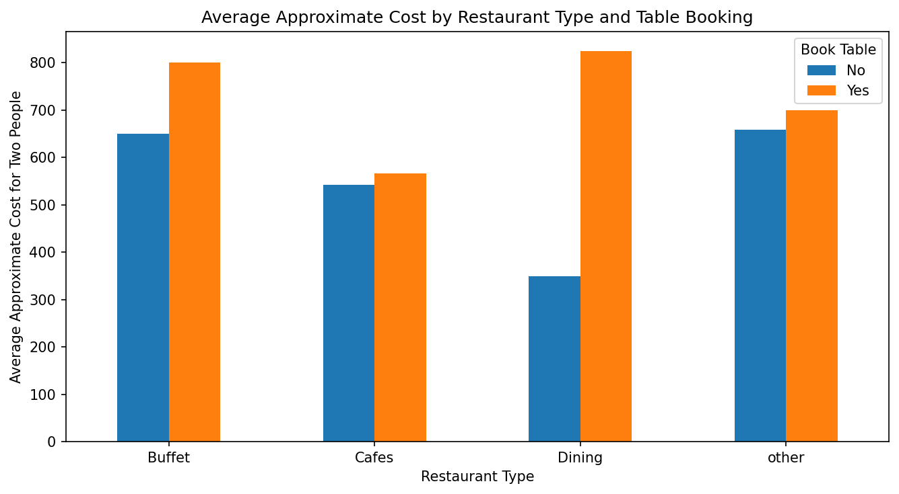
Observation: Average costs differ substantially by restaurant type. For example, Dining averages about ₹357.27 without table booking and ₹825.00 with table booking. Cafes average about ₹542.50 without booking and ₹566.67 with booking.
Business interpretation: Table booking is associated with higher average cost in this sample, especially within Dining. This should not be interpreted as a causal effect because the booking groups are very small.

15. Multivariate Analysis

15.1 GroupBy Analysis
Restaurant Type | Restaurants | Avg. Rating | Avg. Votes | Avg. Cost
Dining | 110 | 3.57 | 185.12 | ₹357.27
Cafes | 23 | 3.77 | 279.74 | ₹545.65
other | 8 | 3.91 | 1170.88 | ₹668.75
Buffet | 7 | 3.84 | 432.57 | ₹671.43

The 'other' category has the highest average rating (3.91) and the highest average vote count (1,170.88), but it contains only 8 records. Buffet has the highest average cost among the categories at about ₹671.43. Dining is the largest category but has the lowest average rating (3.57) and the lowest average cost (₹357.27) among the four categories.

15.2 Correlation Analysis

Correlation Matrix of Numeric Columns
Objective: Measure the strength and direction of linear relationships among votes, rating, and approximate cost.
Why this chart: A correlation matrix summarizes several numeric relationships in one compact view.
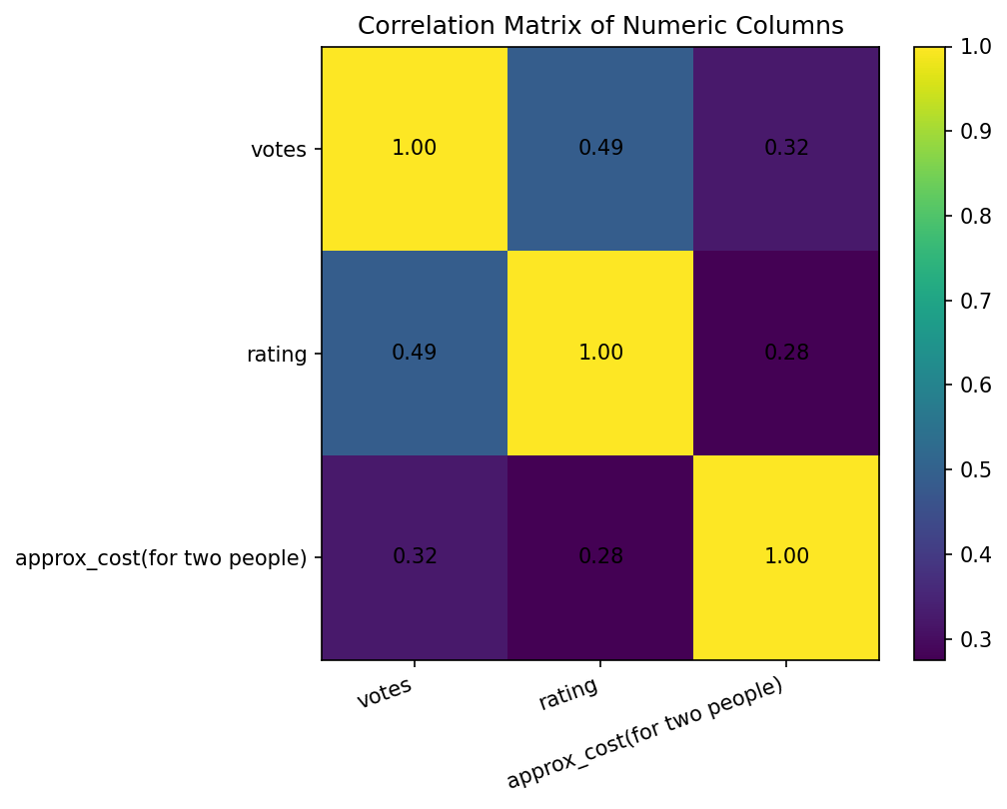
Observation: Votes and rating have a correlation of 0.49; votes and approximate cost have 0.32; rating and approximate cost have 0.28.
Business interpretation: Higher-rated restaurants tend to have more votes in this sample, but correlation does not prove that ratings cause votes. Cost has weaker positive relationships with both votes and rating.

15.3 Pivot-Style Cost Comparison
Restaurant Type | Avg. Cost - Book Table: Yes | Avg. Cost - Book Table: No
Buffet | ₹800.00 | ₹650.00
Cafes | ₹566.67 | ₹542.50
other | ₹700.00 | ₹658.33
Dining | ₹825.00 | ₹348.61

16. Feature Engineering
Feature engineering means creating a new useful variable from existing data. In this project, the original 'rate' field is stored as text, for example '4.1/5'. A numeric 'rating' feature was created by extracting the numeric part.
Example code:
df['rating'] = df['rate'].str.extract(r'([\d.]+)').astype(float)
Business benefit: a numeric rating can be averaged, compared across categories, plotted, and included in correlation analysis. No additional feature was created where the supplied fields did not provide enough evidence.

17. Data Visualization

Online Ordering vs Table Booking
Objective: Show how online ordering availability and table booking availability occur together.
Why this chart: A grouped bar chart is appropriate for comparing two binary categorical variables.
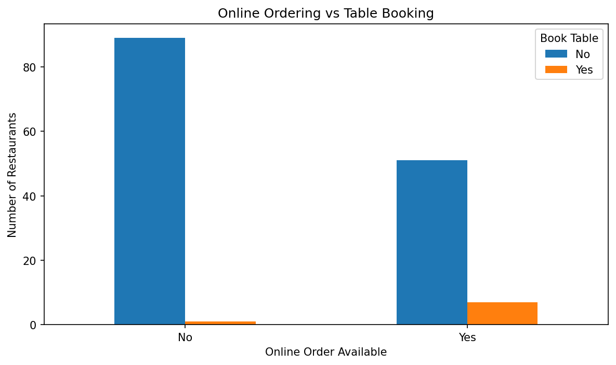
Observation: Online ordering is available for 58 restaurants, while table booking is available for only 8. Among restaurants without online ordering, only 1 has table booking; among online-order restaurants, 7 have table booking.
Business interpretation: Online ordering is much more common than table booking in this sample. This may indicate that digital ordering is a more widely adopted service than table reservation.

Restaurant Rating Distribution
Objective: Understand how restaurant ratings are distributed.
Why this chart: A histogram shows the concentration and spread of a numeric variable.
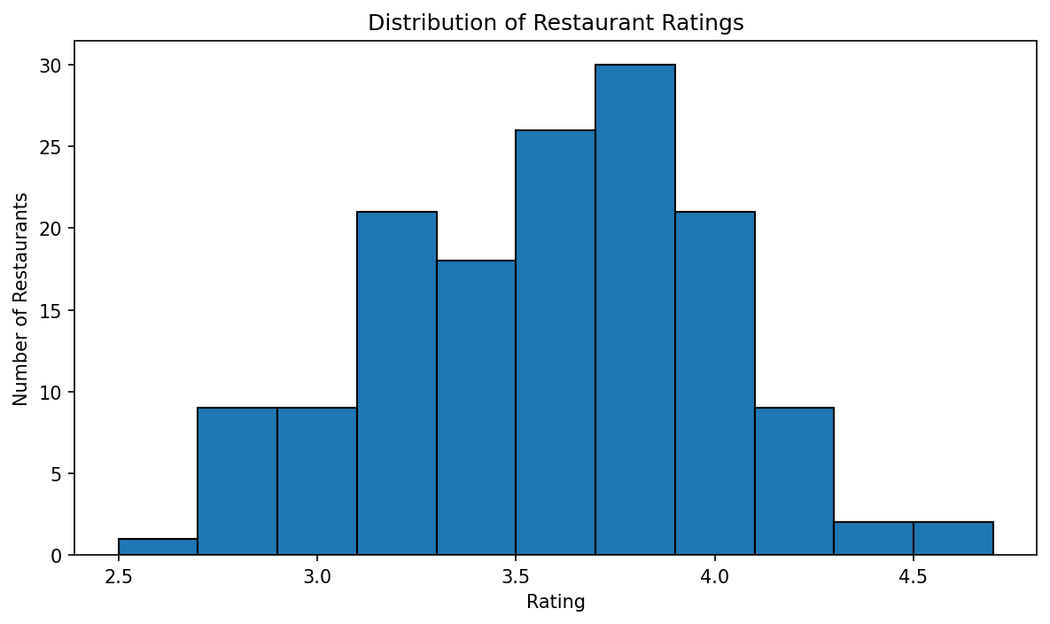
Observation: Ratings range from 2.6 to 4.6, with many observations concentrated around 3.3 to 4.1.
Business interpretation: The sample contains mostly mid-to-high ratings rather than extremely low ratings. Ratings can be used as a quality indicator, but they should be considered alongside vote volume.

18. Business Insights
- Dining is the dominant category: 110 of 148 restaurants (74.3%) are classified as Dining.
- Table booking is uncommon: only 8 restaurants (5.4%) have book-table availability.
- Online ordering is more common: 58 restaurants (39.2%) offer online ordering.
- The average rating is 3.63, while the median is 3.70.
- Customer votes are highly uneven: the median is 43.50, compared with a mean of 264.81.
- The 'other' category has the highest average rating (3.91) and average votes (1170.88), but only 8 restaurants are in that group.
- Buffet has the highest average cost (671.43) among the four categories.
- Dining has the lowest average cost (357.27) and the lowest average rating (3.57) among the four types.
- Votes and ratings show a moderate positive correlation (0.49), while votes and cost show a weaker positive correlation (0.32).

19. Recommendations
Track digital service adoption: Online ordering is much more common than table booking. Restaurants can monitor whether adding or improving digital services changes customer engagement over time.
Evaluate table-booking opportunities carefully: Only 8 restaurants offer table booking in this sample. Restaurants without the service can assess demand before investing, rather than assuming booking will automatically increase revenue.
Use rating and vote volume together: A high rating with very few votes may provide less evidence of broad customer experience than a similar rating supported by many votes.
Benchmark pricing by restaurant type: Average cost varies strongly across categories. Managers can compare their restaurant's price position against the relevant category instead of using the overall average alone.
Investigate high-engagement restaurants: Restaurants with very high vote counts can be studied as benchmarks for customer engagement, digital presence, and service experience.
Collect more complete business data: Future analysis would benefit from location, cuisine, revenue, customer reviews, delivery metrics, and time-based data to support stronger decisions.

20. Challenges Faced
- The rating field was stored as text and required conversion into a numeric feature.
- Vote counts are strongly uneven, so the mean can be influenced by a small number of highly voted restaurants.
- Restaurant categories are imbalanced, with Dining representing most records.
- The table-booking Yes group is very small (8 records), so its averages should be interpreted carefully.
- The dataset does not contain time, location, revenue, cuisine, or detailed review text, which limits deeper business conclusions.
- The supplied PDF did not provide machine-readable text through the file reader; therefore, the report relies on the CSV for calculations and the supplied chart images for visual reference.

21. Conclusion
This project analyzed 148 restaurant records across 8 original fields. The dataset was checked for missing values and exact duplicate rows, and a numeric rating feature was created from the original rating text.
The analysis found that Dining is the largest category, online ordering is substantially more common than table booking, and the average cost for two people is approximately ₹418.24. The relationship between votes and ratings is moderately positive, while cost has weaker positive relationships with votes and ratings.
The analysis demonstrates how basic Python and Pandas techniques can turn restaurant data into practical business information. The results can support category benchmarking, pricing comparisons, digital-service evaluation, and customer-engagement analysis.

22. Future Scope
- Build an interactive dashboard using Power BI or Tableau.
- Add geographic information for city, locality, or neighborhood analysis.
- Analyze customer review text using Natural Language Processing (NLP).
- Build rating or popularity prediction models using machine learning.
- Develop a restaurant recommendation system.
- Track restaurant performance over time with historical datasets.
- Automate the data pipeline so new restaurant data can be analyzed regularly.
- Add delivery time, order volume, revenue, cuisine, and customer-segment variables for richer business analysis.

23. References
- User-provided source dataset: cleaned_zomato_data.csv.
- Python documentation: https://docs.python.org/3/
- Pandas documentation: https://pandas.pydata.org/docs/
- NumPy documentation: https://numpy.org/doc/
- Matplotlib documentation: https://matplotlib.org/stable/
- Seaborn documentation: https://seaborn.pydata.org/
Note: External documentation links are included as standard technical references. All project-specific observations and calculations in this report are based on the supplied dataset.

Appendix A - Top 10 Restaurants by Votes
Restaurant | Rating | Votes | Approx. Cost | Online Order | Book Table | Type
Empire Restaurant | 4.4 | 4884 | ₹750 | Yes | No | other
Meghana Foods | 4.4 | 4401 | ₹600 | Yes | No | Dining
Onesta | 4.6 | 2556 | ₹600 | Yes | Yes | Cafes
Onesta | 4.6 | 2556 | ₹600 | Yes | Yes | other
Kabab Magic | 4.1 | 1720 | ₹400 | Yes | No | Dining
Szechuan Dragon | 4.2 | 1647 | ₹600 | Yes | No | Dining
Roving Feast | 4.0 | 1047 | ₹450 | No | No | Dining
San Churro Cafe | 3.8 | 918 | ₹800 | Yes | No | Buffet
San Churro Cafe | 3.8 | 918 | ₹800 | Yes | No | Cafes
Gustoes Beer House | 4.1 | 868 | ₹700 | No | No | Dining

